British Bangladeshi Business Family wins ‘Spice up Your Life’ IPRA Golden World Award www.ipra.org 2017 at an International Ceremony in Sofia, Bulgaria.

Speaking after winning an International Public Relations (IPRA) Golden World Award, Neela Farzana Hosain, MD of Neela’s Home Ltd said that as a small immigrant family they had two options: working in a supermarket stacking shelves or working the till point. Maybe even having to receive welfare if they could not find employment. Neela and her family did not want such a picture for their lives and strongly believed that they could start a business. They joined 10 million Bangladeshi people living in the UK who have the potential to become self-employed business owners. https://www.ipra.org/golden-world-awards/winners/

They decided to start their own business to enable them to buy their own home and along the way employ and contribute to others, right down to Bangladeshi farmers and their families who grow the spices that Neela’s Home Ltd sell. But Neela hit a barrier when she asked her husband Bulbul to fund the start-up. He was reluctant to invest and asked. ‘Why are you asking me to throw my money into the river?’.

She added: ‘Finally he accepted and gave his full support. Today, thanks to hard work with my husband, family and a great team by my side, combined with the power of public relations, we are aiming to have a multimillion dollar company that sells not just in 7 countries, but around the world’. Bulbul also admits that investing in his wife was the best investment he has ever made. www.neelashome.com

Because we started this company our lives have changed completely and we are humbled and honoured that Neela’s Home Ltd received this amazing award from IPRA. We are here today receiving this award because of hard work and the IPRA power of public relations. In 2015, Neela received a Best Business Woman Entrepreneur of the Year’ with an award presented by the former British Prime Minister, David Cameron, at the U.K.’s first British Bangladeshi Business Awards, in London. And now Neela’s Home wins an IPRA Golden World Award.

She has worked with PR consults Jasper Alliance London Limited for many years taking wise counsel about the need to publicise achievements and milestones. www.jasperalliancelondon.com

Neela adds a funny story: ‘My Auntie called my Mum and asked: ‘How can Neela win such an award when all she does is sell chilli powder, turmeric and spices?’. My Mum had to explain that we developed a business selling spices. Neela adds: ‘Today we own our home and all our family members work in the company, but my relatives still cannot believe our success’

.
Neela’s final words: ‘Buy my Spices and Spice up Your Life!’ www.neelashome.com

ENDS.

For further information contact: Jacqueline Purcell purcell@jasperalliancelondon.com
Mobile: + 44 (0)7884413305
www.jasperalliancelondon.com

Neela and her family after winning the IPRA Golden World Award

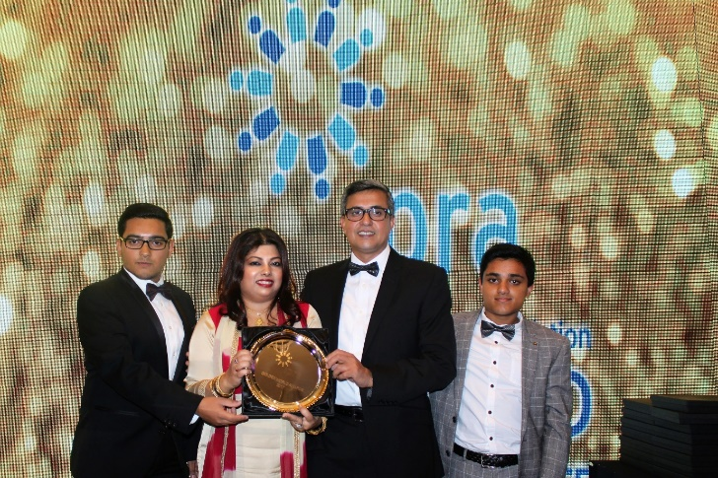

Neela and her husband, Bulbul receive the Golden World Award from IPRA President Bart de Vries.
